**BEVERAGE & BREAKFAST**

**SALES DATASET FOR 2011/2012/2013**

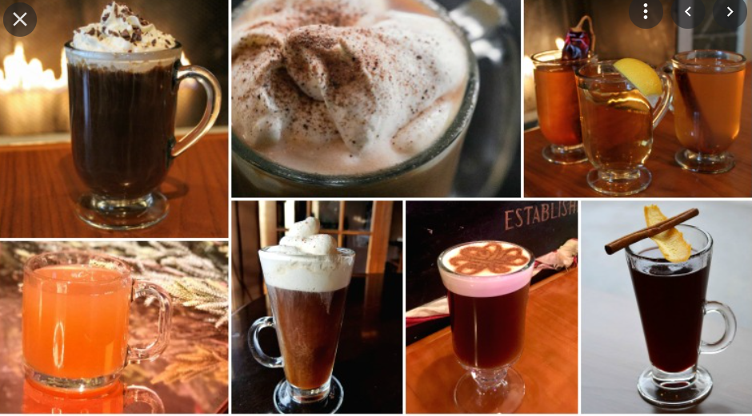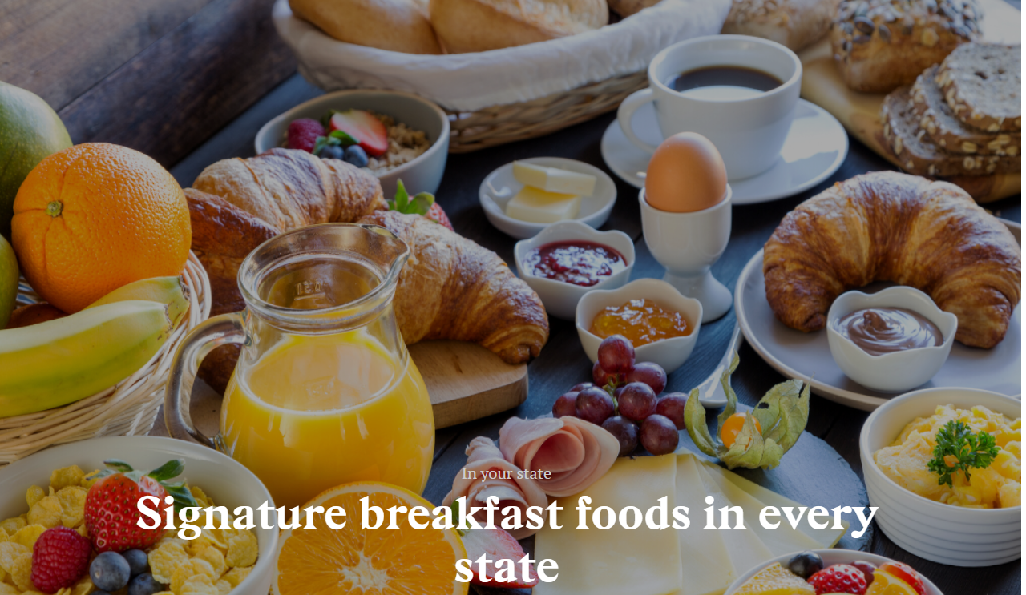

**SALES DATA FOR 2011**

|  |  |
| --- | --- |
| **Row Labels** | **Sum of Total Sales 2011** |
| Beverage | 275075 |
| Drug | 16616 |
| Food | 1156997 |
| Gambling | 79477 |
| Hygeine | 591 |
| Leisure | 17735 |
| **Grand Total** | **1546491** |

**SALES DATA FOR 2012**

|  |  |
| --- | --- |
| **Row Labels** | **Sum of Total Sales 2012** |
| Beverage | 17.79% |
| Drug | 1.07% |
| Food | 74.81% |
| Gambling | 5.14% |
| Hygeine | 0.04% |
| Leisure | 1.15% |
| **Grand Total** | **100.00%** |

**SALES DATA FOR 2013**

**COMPARISION FOR 3 YEARS OF SALES**

|  |  |  |  |
| --- | --- | --- | --- |
| **Row Labels** | **Sum of Total Sales 2011** | **Sum of Total Sales 2012** | **Sum of Total Sales 2013** |
| Beverage | 275075 | 277831 | 282984 |
| Drug | 16616 | 16781 | 17081 |
| Food | 1156997 | 1168570 | 1191312 |
| Gambling | 79477 | 80269 | 81808 |
| Hygeine | 591 | 598 | 613 |
| Leisure | 17735 | 17912 | 18284 |
| **Grand Total** | **1546491** | **1561961** | **1592082** |

**INFERANCE OF THE SALES EACH YEAR**

Sales shows increasing trend by each year for cold /Hot/Neutral beverages & breakfast

Sales shows increasing trend by each year product wise for each year

Sales shows increasing trend by sub category wise